An Automated Student Services with Tracking



|  |  |
| --- | --- |
| Muhammad Faisal | 53929 |
| Aneeq Sohail | 53571 |
|  |  |

DEPARTMENT OF SOFTWARE ENGINEERING

**BALOCHISTAN UNIVERSITY OF INFORMATION TECHNOLOGY, ENGINEERING, AND MANAGEMENT SCIENCES**

**Spring 2023**

An Automated Student Services with Tracking



By

|  |  |
| --- | --- |
| Muhammad Faisal | 53929 |
| Aneeq Sohail | 53571 |

|  |
| --- |
| Supervisor: Dr. Bakhtiar Khan Kasi  Co-Supervisor: Muhammad Akram Khan |

DEPARTMENT OF SOFTWARE ENGINEERING

**BALOCHISTAN UNIVERSITY OF INFORMATION TECHNOLOGY, ENGINEERING, AND MANAGEMENT SCIENCES**

**Spring 2023**

An Automated Student Services with Tracking

by

|  |  |
| --- | --- |
| Muhammad Fasial | 53929 |
| Aneeq Sohail | 53571 |

A project report submitted to the

**Department of Software Engineering**

in partial fulfillment of requirements for the degree of Bachelor of Science in Software Engineering at Balochistan University of Information Technology, Engineering and Management Sciences

Spring 2023

Signature of Supervisor: ___________________________________________________________

Signature of FYP Coordinator: _______________________________________________________

Signature of Co-Supervisor (If any): __________________________________________________

# **Undertaking**

It is certified that this work titled “**An Automated Student Service with Tracking**” is our own work. The work has not been presented elsewhere for assessment. Where material has been used from other sources it has been properly acknowledged / referred to.

______________________

Muhammad Faisal

53929

______________________

Aneeq Sohail

53571

# **Acknowledgments**

The acknowledgments and the people to thank here.

# **Dedication**

Decide who will be the focus. Think about the people to whom you want to dedicate this work.

|  |  |  |  |  |
| --- | --- | --- | --- | --- |
| *\*All information in this form should be typed.* **Date:** Day / Month / Year | | | | |
| **1. Project Title: An Automated Student Service System with Tracking** | | | | |
| **2. Supervisor Details:** | | | | |
| **Supervisor Name** | Dr. Bakhtiar Khan Kasi | | | |
| **Designation** | Professor/Dean | | | |
| **Department** | Computer Engineering | | | |
| **Research Group (if any)** |  | | | |
| **3. Group Members:** | | | | |
| **Name** | **CMS ID** | **CNIC No.** | **Contact No.** | **Email** |
| Muhmmad Faisal Khan | 53929 | 5420384023943 | 03228361832 | Faisalkakar0056@gmail.com |
| Aneeq Sohail | 53571 | 5440199235863 | 03158843532 | aniqsohail@gmail.com |
|  |  |  |  |  |

|  |  |
| --- | --- |
| C:\Users\Fast\Desktop\Balochistan University Logo.jpg | **Balochistan University of Information Technology, Engineering and Management Sciences, Quetta** |
| BUITEMS | *Quality & Excellence in Education* |
| **Final Year Project Intellectual Property Form, FICT** | |
| *Project Title: An Automated Student Service with Tracking* | |

**Declaration**

I agree that the information related to the project titled ___________________________________________ under the supervision of _____________________________ will be kept confidential. This includes:

1. All the technical and scientific data relating to project discussions, research, design and simulation, processes, and business and/or marketing plans that are developed or are under development.
2. This information will be disclosed solely to individuals who have a signed non-disclosure agreement with, or who have express approval from **_____(Supervisor Name)_____** and **_____(HOD Name)_____**, in written, to receive this information.

Understood and agreed on the ___(nth day)___ of ______(month)_______ in ____(year)____.

|  |  |
| --- | --- |
| **4. Group Members Signature:** | |
| **Members’ Name** | **Signatures** |
| Muhammad Faisal Khan |  |
| Aneeq Sohail |  |
|  |  |

|  |  |  |
| --- | --- | --- |
| **5. Supervisor Remarks:** | | |
| **Supervisor Name** | **Remarks** | **Signature/Stamp** |
|  |  |  |

# **Abstract**

An abstract is a brief outline or summary of your paper and project. It should have an intro, body, and conclusion. It is a well-developed paragraph, should be exact in wording, and must be understandable to a wide audience. Must not exceed the 250-300 words limit.

**Keywords:** Keyword-1, Keyword-2…

**Table of Contents**

**Undertaking** iv

**Acknowledgements** v

**Dedication** vi

**Final Year Project Intellectual Property Form, FICT** vii

**Abstract** viii

**1** **INTRODUCTION** 1

**1.1** **Background** 1

**1.2** **Problem statement** 1

**1.3** **Objective** 1

**1.4** **Scope** 2

**1.5** **Significance of the Study/ Mapping FYP with Sustainable Development Goals (SDGs)** 2

**1.6** **Organization of the Thesis** 2

**2** **LITERATURE REVIEW** 3

**2.1** **Review of (Similar Applications / Existing Research)** 4

**2.2** **Related Projects and Case Studies** 4

**2.3** **Summary** 4

**3** **METHODOLOGY** 5

**3.1** **Tools** 5

**3.2** **Research Design** 6

**3.3** **System Features** 6

**3.4** **Project Planning** 6

**3.5** **Project Design** 6

**3.5.1** **Diagrams** 6

**3.5.2** **Algorithm Design** 6

**3.6** **Ethical Consideration** 6

**4** **DEVELOPMENT AND TESTING / RESULT AND DISCUSSION** 7

**4.1** **Simulation & Experimentation** 7

**4.2** **Results** 7

***4.2.1*** ***Tables*** 8

***4.2.2*** ***Figures*** 8

**4.3** **Discussion** 8

**4.4** **Comparison with Previous Studies** 8

**4.5** **Limitations and Validity** 9

**4.6** **Testing Plan** 9

**4.7** **Test Results** 9

**4.8** **Deployment** 9

**5** **CONCLUSION AND FUTURE WORK** 10

**5.1** **Conclusion** 10

**5.2** **Future Work** 10

**References** 11

**APPENDIX A** 12

**List of Figures**

Figure 1: A typical embedded hardware architecture 8

**List of Tables**

Table 1: Students Detail 8

**Chapter No. 1**

# **INTRODUCTION**

As technological advances grow over time, there is a need for everyday processes, businesses, and services to evolve accordingly to walk along such advancements. A similar scenario is expected for student services in universities which requires the need to design and build a user-friendly system. Designing and building a system for student e-services makes everyday life easier for educational institutions to manage their frequent activities and services efficiently. It will imply that the students, student union, and university administration will be able to interact, communicate, and help with their activities related services. It will help generate error-free outcomes which may not be the case with manual processes and practices.

In today’s life scenario, it is not easy to keep the information on paper. This is what triggers why it is essential and preferable to have an online computerized system based on a database design. It will be suitable for every organization, no matter how small or big. For example, a database application system was developed in [1]. It evaluates the contents of the work done by students. It was meant to effectively perform the responsibility of the departments. It covers various basic student information to effectively manage and process. It meets the requirements of how student workers operate and is useful for carrying on the data processing. A feasible solution was provided in [2] to develop a teaching management system. It was achieved by designing a database with a nice structure, storage efficiency, and independence.

An automated system is assisted by computers, it allows the data to flow in an efficient way Designing, building and implementation can be assisted by various technologies to lead towards a computer-based system for automated student management systems. To develop the proposed system, some important tools have been utilized to configure the database, and design interfaces. For example, SQL (Structured Query Language) is used to communicate with databases. MySQL Workbench is utilized to create, develop, access, manage, and analyze data. Tools such as ReactJS, Tailwind CSS, and Nodejs were used, as the primary programming languages, for creating the website for the developed system. VsCode was used, as a text editor, for coding.

In this work, we aim to develop an automated management system for student services in an educational institution environment. The students, student union, and administration can share various services including making Student Cards, requesting for CMS Password Reset, requesting a Name Correction, uploading documents, and contacting department head. The objective, of this Software, is to introduce and deliver a friendly and efficient system so that there is a significant enhancement in productivity for University students, student unions, administration, or other users as need be.

In this work, we build and design a database and transform a current mechanism into a robust computerized system. It will ease, help, and automate processing the service activities by replacing the traditional paper-based system. The proposed system has been initiated and strengthened by a survey that helps to find out the requirements to design the system. It is then followed by building a database. Then, various other phases have been incorporated which include planning, analyzing, and designing the system. As far as the implementation of the proposed system is concerned, after consideration and evaluation of numerous existing technologies, we decided upon the most popular and beneficial options to build the proposed system. As a case study, Kuwait University of Kuwait is taken as an environment. However, the build system can be implemented in any other environment with some specific orientations according to the required needs. The proposed system is secure, robust, accurate and efficient. It is accessible through web from anywhere and anytime

## **Background**

In the past, manual procedures and uncoordinated systems have frequently affected university student assistance services. Due to paper-based operations, departmental communication lag, overworked personnel completing repetitive activities, and general student annoyance, this resulted in lengthy return times. In response to these difficulties, automated student service systems with tracking arose. By digitizing forms, automating communication, centralizing services into a single platform, and providing application tracking, these solutions streamline workflows. This increases staff productivity and offers data-driven insights for the institution's decision-making, all of which contribute to a markedly better student experience with quicker resolutions and increased transparency.

## **Problem statement**

Outdated processes and communication breakdowns hinder the institution's ability to provide timely and effective support to students, impacting the overall student experience.

Delays due to paper processes, lack of updates for students, fragmented communication, and staff overburdened by manual tasks. This creates a frustrating and ineffective experience for both students and staff. Our software has the features of a centralized ticketing system, and document scanning capabilities to reduce the paperwork. The goal is to improve the efficiency of the problem-solving process, reduce paperwork, and enhance the overall student support experience.

## **Objective**

* Automate student service processes: Develop a web-based system that automates manual student service processes, such as name corrections, CMS resets, and fee issue resolution.
* Provide real-time tracking: Enable students to track the status of their requests in real-time through a centralized dashboard.
* Reduceadministrativeburden**:**Streamline administrative workflows and free up administrative staff from time-consuming manual tasks
* Better communication: Facilitate effective communication between students and administrative staff by providing a dedicated platform for student-administrative interactions
* Ticket Creation: Students can easily submit tickets describing their problems in detail. Consider structured forms with dropdown menus, input fields, and areas to categorize issues (academic, technical, administrative, facilities, etc.).

## **Scope**

The product is a software application that is accessed from a web browser and generates a ticket which used to solve and track any type of problem students face. This system would include intuitive forms for ticket creation, enabling students to provide detailed descriptions and upload any relevant supporting documents the product offers real-time document scanning capabilities. Students can directly use their smartphone's camera to scan and upload necessary documents, reducing paperwork hassle.

## **Significance of the Study/ Mapping FYP with Sustainable Development Goals (SDGs)**

Discuss the potential impact and benefits of your project. Explain how your project will contribute to the field, industry, or society. Identify any potential stakeholders or beneficiaries of your project's outcomes.

Additionally, aligning your Final Year Project (FYP) with the United Nations' Sustainable Development Goals (SDGs) is mandatory. The SDGs offer a comprehensive framework for addressing global challenges and fostering sustainable development across sectors.

## **Organization of the Thesis**

Provide an overview of the structure and organization of your thesis. Briefly describe what each chapter or section of your thesis will cover. Explain how the chapters are interconnected and how they contribute to addressing the objectives of your project.

The introduction should be at least 3 pages with a detailed explanation of why the project is important. You may also add a market survey to support your idea, etc.

**Chapter No. 2**

|  |
| --- |
| **REMOVE THIS TABLE AFTER GIVING IT A PROPER READ, AS IT IS JUST TO GIVE THE FORMATTING INFORMATION:** |
| Watch this video to learn more about references in IEEE: <https://youtu.be/Mmj_pc4IkZQ>  You can also read this guide: <https://ieeeauthorcenter.ieee.org/wp-content/uploads/IEEE-Reference-Guide.pdf>  **Helpful Tools/ Online Resources:**   * <https://www.mybib.com/> * <https://scholar.google.com/> * <https://www.mendeley.com/>   **Use IEEE citation style:** In this thesis, we will follow the IEEE citation style for referencing and citing sources. IEEE style is widely used in the field of engineering, computer science, and related disciplines. It provides a standardized format for citing various types of sources, including books, journal articles, conference papers, and websites. Please make sure to adhere to the IEEE citation guidelines throughout your thesis [2].  **Utilize MS Word's citation features:** Microsoft Word offers built-in features that can assist you in managing your citations and references. You can use the "References" tab in MS Word to create a bibliography, insert in-text citations, and manage your reference list. Familiarize yourself with these features to ensure accurate and consistent citations throughout your thesis. |

# **LITERATURE REVIEW**

Literature review must include references of journal articles, books, conference, and research papers from the past five years. It is recommended to include a minimum of twenty citations or references in this chapter of your thesis.

Provide an overview of the purpose and significance of the literature review. Explain how the literature review will contribute to your project and address the research questions or objectives.

## **Review of (Similar Applications / Existing Research)**

**NOTE: For HARDWARE and RESEARCH-BASED PROJECTS, the heading of this Section should be " Review of Existing Research". For SOFTWARE-BASED APPLICATION PROJECTS, the heading of this Section should be "Review of Similar Applications"**

Summarize and critically analyze existing research/application, studies, or projects related to your topic. Identify key themes, trends, or gaps in the existing literature. Highlight the strengths and weaknesses of previous approaches or methodologies [3].

## **Related Projects and Case Studies**

This heading is **optional**. Describe any relevant projects or case studies that are similar or related to your project. Discuss their methodologies, findings, and lessons learned. Analyze how their outcomes or approaches can inform and support your own project.

## **Summary**

This heading is **optional**. Summarize the key findings and insights from the literature review. Identify any gaps or areas where further research is needed. Explain how the literature review has informed the development of your project and its methodology.

This chapter of the FYP refers to the existing work that is related to this project. The literature review chapter provides a detailed review, discussion, and comments on existing work that contributes to this study.

**Chapter No. 3**

# **METHODOLOGY**

**REMOVE THIS PORTION AFTER GIVING IT A PROPER READ, AS IT IS JUST TO GIVE THE INFORMATION REGARDING THIS CHAPTER:**

Provide an overview of the methodology chapter. Explain the purpose of this chapter, which is to describe the approach and methods used to address the problem statement and test the hypothesis.

Reiterate the problem statement briefly for reference. Explain how the selected methodology will help in addressing the identified problem.

You can insert flowcharts or diagrams at relevant points to enhance the understanding of your methodology. Consider placing them after the section that explains the corresponding steps or processes. Ensure that each flowchart or diagram is properly labeled, referenced, and explained in the text. Use clear and concise captions to guide readers and refer to the diagrams within the text when discussing specific steps or components.

Including visual representations such as flowcharts and diagrams can significantly enhance the clarity and comprehension of your methodology. However, it's important to strike a balance between providing sufficient detail in the text and using visual aids effectively. Use flowcharts and diagrams as supplementary materials to support and complement the written explanation of your methodology.

**NOTE: SECTION 3.1, 3.2, and 3.6 should be a part of this chapter for RESEARCH-BASED PROJECTS. These projects need to remove SECTION 3.3, 3.4 and 3.5 from this document.**

**NOTE: SECTION 3.3, 3.4, 3.5 and 3.6 should be a part of this chapter for SOFTWARE-BASED APPLICATION PROJECTS. These projects need to remove SECTION 3.1 and 3.2 from this document.**

## **Tools**

This system and its development are from scratch. One can see the resulting implementation can capture and implement all desired requirements for a student service administration system. The underlying database technology, together with web design technologies and programming languages, have been used in the development of a system that would fulfill all the system requirements. Here is the mention of the tools that have been used to configure the database and interfaces in the development of the system:

1. **ReactJs**: is the primary programming language we use when creating a website.
2. **Node.js:** is a JavaScript runtime built on Chrome's V8 JavaScript engine, used for building server-side applications.
3. **Tailwind CSS:** is a utility-first CSS framework that provides low-level utility classes to quickly build custom designs
4. **SQL**: Structured Query Language is used to communicate with the database.
5. **MySQL Workbench**: create, develop, access, manage, and analyze data.
6. **Visual Studio Code (VS Code):** is a free source code editor developed by Microsoft for Windows.
7. **Figma:** is a web-based collaborative interface design tool used for creating interactive prototypes and user interfaces.
8. **Google Chrome**: is a popular web browser developed by Google, known for its speed, simplicity, and support for modern web standards.
9. **PC**: for coding.
10. **NPM (Node Package Manager)**: is a package manager for Node.js packages, modules, and libraries.

## **Research Design**

Describe the overall research design or experimental setup employed in your project. Discuss the approach or methodology used to collect data or conduct experiments. Explain how the research design aligns with the objectives of your project.

## **System Features**

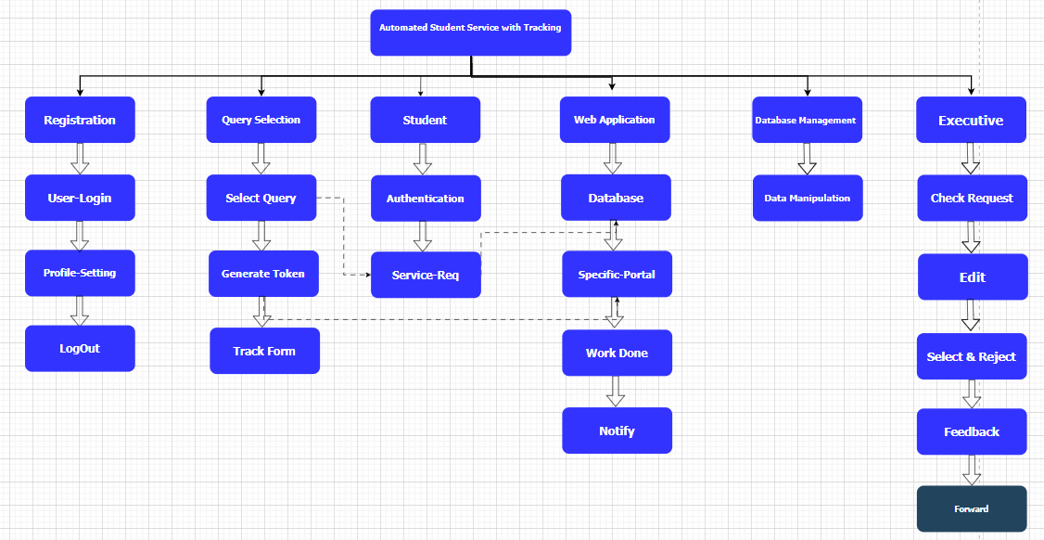

Figure : System Features

### ***Student Dashboard Features***

* Students can contact to department chairperson through the student portal.
* Students track their application progress through the tracking ID.
* Students receive the notification when the chairperson sends a message.
* Students can edit their profile from the dashboard.
* Students view their submitted applications from the dashboard.

### ***Chairperson Dashboard Features***

* Chairperson views students application.
* Chairperson has powers to accept, reject, or forward student applications.
* Chairperson receives the notification when the student applies.
* Chairperson edit their profile details from their portal.

### ***Admin Dashboard Features***

* Admin only receives applications which are accepted by the chairperson.
* Admin has powers to accept, reject, or forward student applications.
* Admin also views the student-uploaded documents.
* Admin notifies chairperson related to application.

### ***Tracking Feature***

Application management is the heart of an automated student service system, especially when it includes application tracking. An application tracking module facilitates the entire application journey. It simplifies processes for students by providing clear online forms and secure document upload areas. This module tracks application progress, sending timely status updates and allowing for direct communication with applicants. This streamlines the process significantly, enhancing both the student and institutional experience

## **Project Planning**

***Gant Chart***

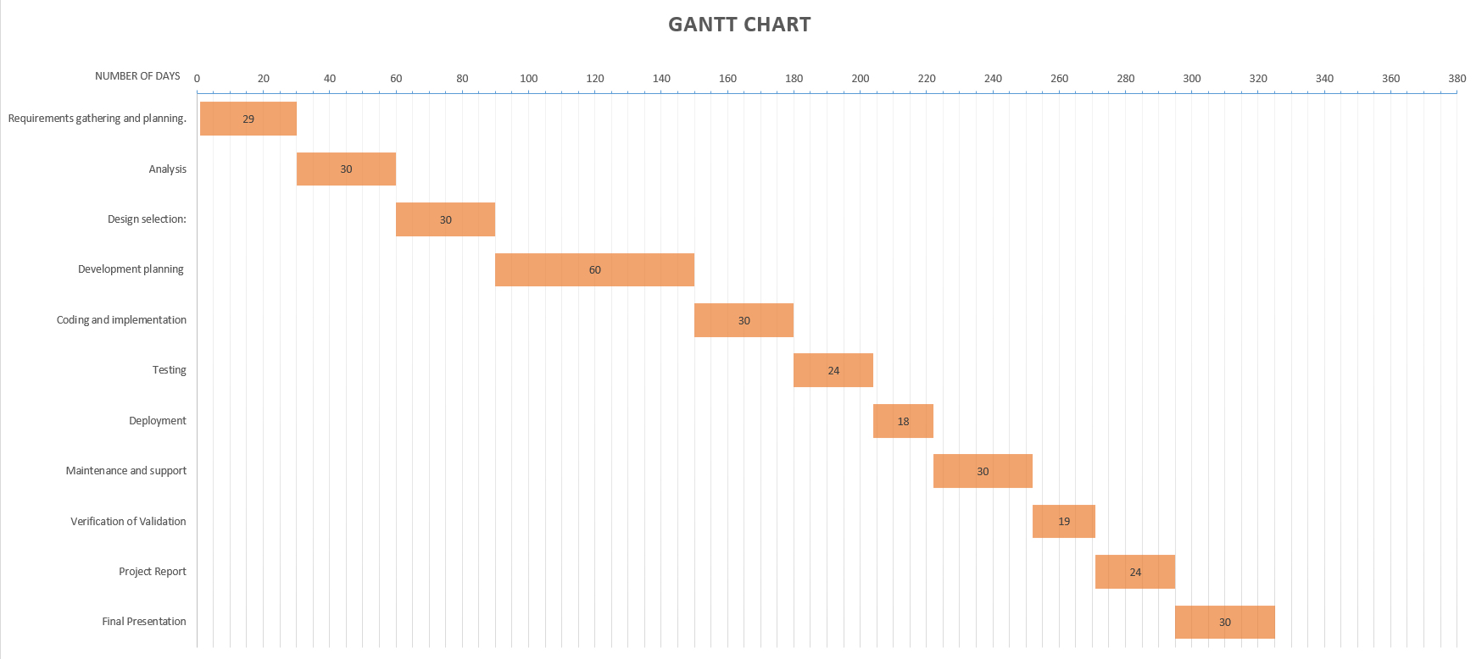

Figure Gantt Chart

### ***Task Distribution***

|  |  |
| --- | --- |
| Student Name | Tasks |
| Muhammad Faisal Khan | Code implementation, Documentation, Database design. |
| Aneeq Sohail | Code implementation, Documentation, and front-end design. |

Table : Distribution of Work

## **Project Design**

### **Diagrams**

This heading includes Use case diagram with description, Activity Diagram, Sequence diagram, DFD, ERD/Dataset.

***Login***

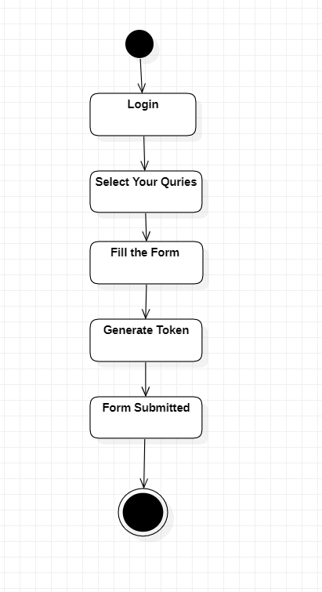

Figure Use Case Daigram of Login

***Queries Selection***

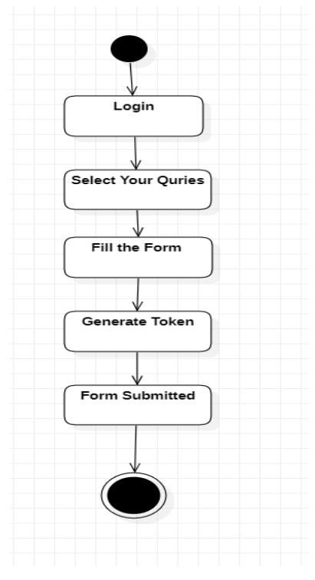

Figure Queries Selection for Student

***Student Notification:***

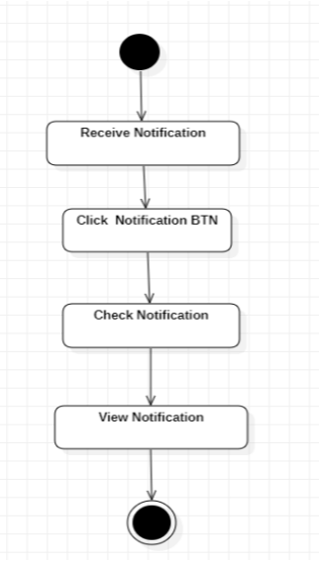

Figure Use Case Daigam Student Notification

***CMS Password Reset:***

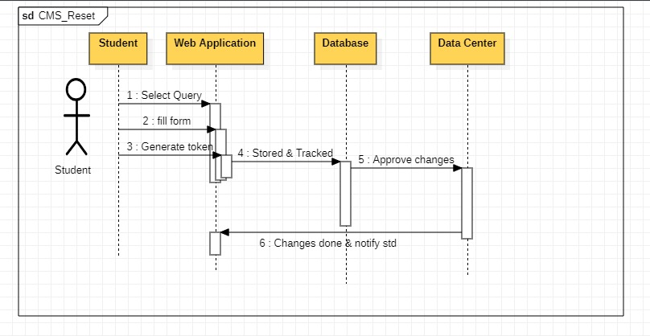

Figure : Sequence daigram of CMS password reset

***Name Correction:***

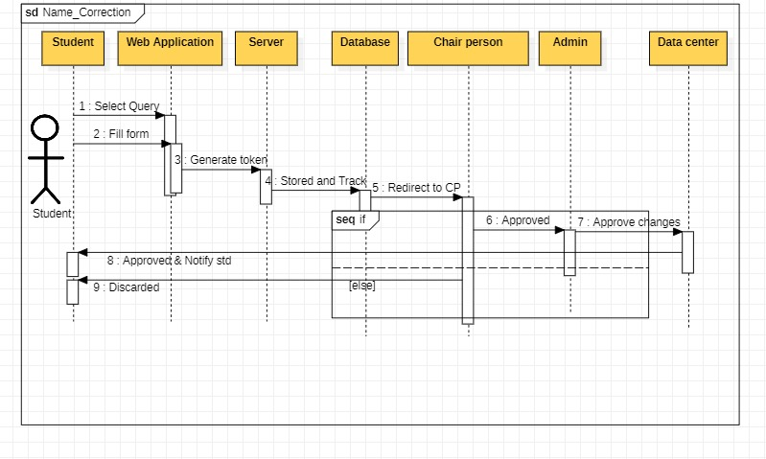

Figure Use Case of Name Correction

***Chairperson Notification:***

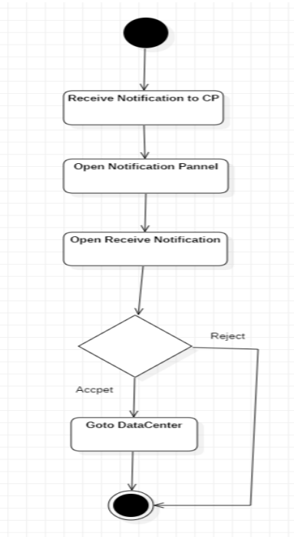

Figure Use case of Chairperson Notification

***Document Uploading:***

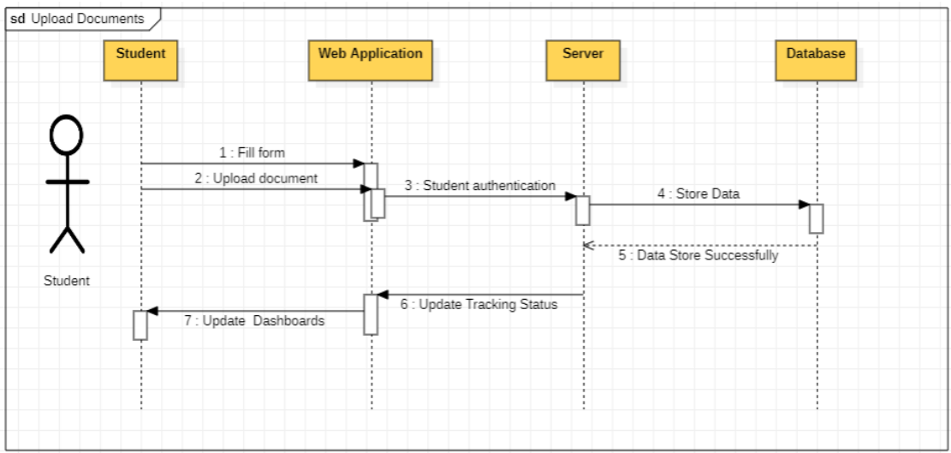

Figure Sequence Daigram of Document uploading

***ERD Daigram:***

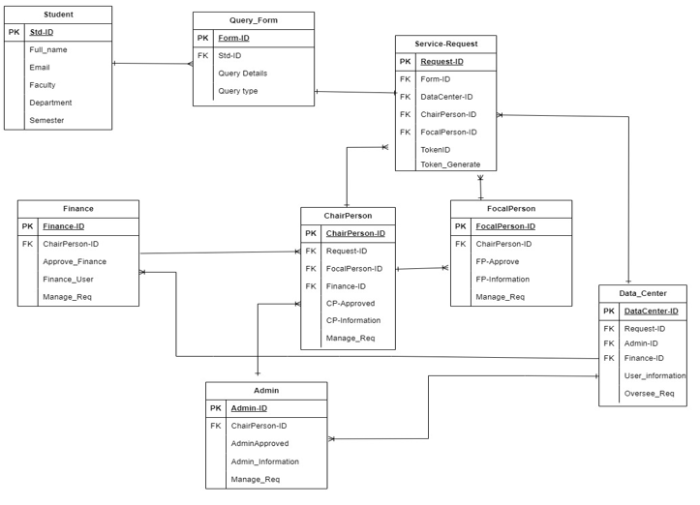

Figure : ERD daigram of entire system

***Use Case Diagram:***

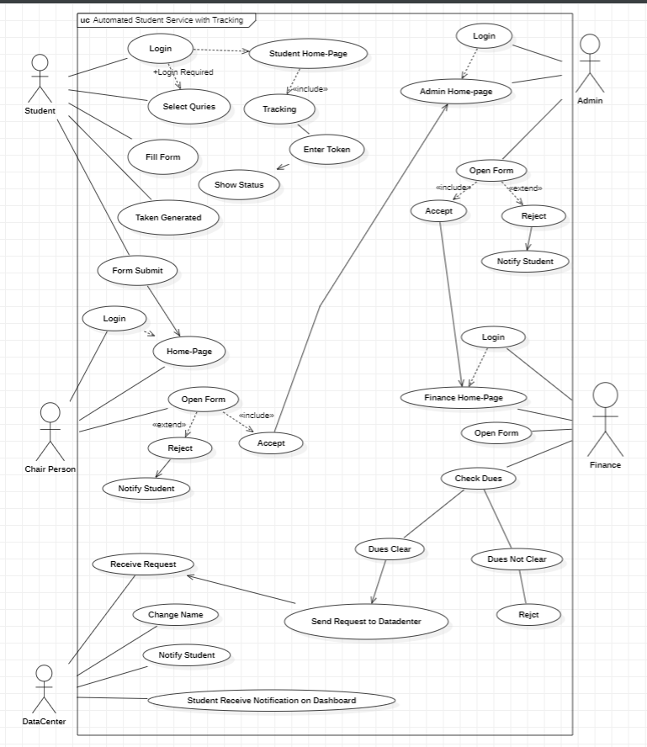

**Chapter No. 4**

# **DEVELOPMENT AND TESTING /** **RESULT AND DISCUSSION**

**REMOVE THIS PORTION AFTER GIVING IT A PROPER READ, AS IT IS JUST TO GIVE THE INFORMATION REGARDING THIS CHAPTER:**

**NOTE: For HARDWARE and RESEARCH-BASED PROJECTS, the heading of this Chapter should be "RESULT AND DISCUSSION". SECTION 4.1, 4.2, 4.3, 4.4 and 4.5 should be a part of this chapter for such projects. These projects need to remove SECTION 4.6, 4.7 and 4.8 from this document.**

**NOTE: For SOFTWARE-BASED APPLICATION PROJECTS, the heading of this Chapter should be "DEVELOPMENT AND TESTING". SECTION 4.6, 4.7 and 4.8 should be a part of this chapter for such projects These projects need to remove SECTION 4.1, 4.2, 4.3, 4.4 and 4.5 from this document.**

Provide an overview of the chapter, highlighting the testing methodologies conducted in your project. Explain the purpose of this chapter, which is to present the details of the testing setup, procedures, and outcomes.

## **Simulation & Experimentation**

Detail the equipment, materials, or software used in your experiments. Describe the setup or configuration of the experimental environment. Include any relevant diagrams, photographs, or schematics to illustrate the experimental setup, if applicable. This should also include a step-by-step description of the experimental procedure. Explain how each variable was manipulated or controlled during the experiments. Clearly outline any instructions given to participants or operators.

## **Results**

Present the results of your experiments or investigations in a clear and organized manner. Use tables, figures, charts, or graphs to effectively communicate the findings. Provide sufficient detail and labels for each result to ensure clarity.

### ***Tables***

As can be seen in Table 1, tables are a great way to show results. Always cite your tables in the text.

Table 2: Students Detail

|  |  |  |  |  |
| --- | --- | --- | --- | --- |
| **S.No** | **Name** | **CMS** | **Department** | **GPA** |
| 1 | Maqsood | 3776 | CE | 3.2 |
| 2 | Waqas | 3456 | CE | 3.1 |
| 3 | Yasir | 3467 | CE | 3.4 |
| 4 | Basit | 6544 | CE | 3.2 |

### ***Figures***

As can be seen in Figure 1, figures are a great way to show results graphically. Always cite your figures in the text.

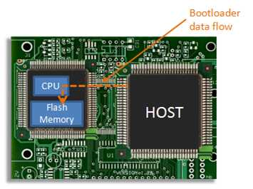

Figure 11: A typical embedded hardware architecture

## **Discussion**

Interpret the results and analyze their significance in relation to the research objectives. Discuss any unexpected or contradictory findings and propose possible explanations. Relate the results back to the existing literature and theories, highlighting similarities or differences.

## **Comparison with Previous Studies**

You can include this heading in your thesis report **only if it is applicable**. Compare your results with those of previous studies or relevant benchmarks. Discuss any similarities, differences, or trends observed. Identify any gaps or areas for further investigation based on the comparison.

## **Limitations and Validity**

Address the limitations of your study, including any constraints or factors that may have influenced the results. Discuss the validity of your findings and any measures taken to ensure the reliability and accuracy of the results.

## **Testing Plan**

Describe the design of your test cases and their output for different modules. This should be in the form of a table consisting of the test cases that you have conducted, what the expected result should be and what the actual result was.

## **Test Results**

This section should include the results in form of screenshot for every test case mentioned in Section 4.1. The test results should be separated module wise.

## **Deployment**

This heading is **optional**, if you are required in the scope of your project to deploy your software in the market then provide the evidence of the system being successfully deployed and is being used. (Evidence may include screenshots of the project being hosted on the user’s domain or User training).

**Chapter No. 5**

# **CONCLUSION AND FUTURE WORK**

## **Conclusion**

This project assists in automating the existing manual system. This is a paperless work. It can be monitored and controlled remotely. It reduces the manpower required. It provides accurate information always All years together gathered information can be saved and can be accessed at any time. The data which is stored in the repository helps in making intelligent decisions by the management. So it is better to have a Web-Based Management system. All the Students, faculty, and management can get the required information without delay. This system is essential in universities.

## **Future Work**

Currently, this software is only for universities. But in the future, It can be expanded and enhanced to incorporate more departments, colleges, institutes, and universities. Specifically, in the case when the number of students, administrators, colleges, and universities increase in size and hence the paper-based systems start to become more apparent as limitations, the benefits of such a system become even more obvious. We will further modify our web app by adding new functionalities or modules. By using other techniques, we can make it better and faster and also, we can update its security by adding encryption algorithms to make it more secure. We can also develop an Android app in the future to make it more accessable.

# **References**

|  |  |
| --- | --- |
| [1] | H. Zhou, "Design of Student Information Management Database Application System for Office and Departmental Target Responsibility System," Physics Procedia, International Conference on Solid State Devices and Materials Science 1660-1665, 2012. |
| [2] | Tang, Shelden, D. R and C. Pardis , "A review of building information modeling (BIM) and the internet of things (IoT) devices integration: Present status and future trends," *Automation in Construction,* vol. 101, no. Elsevier, pp. 127-139, 2019. |
| [3] | R. Weatherall, "Writing the doctoral thesis differently," *Management Learning,* vol. 50, no. SAGE Publications Sage UK: London, England, pp. 100-113, 2019. |
| [4] | Z. L. a. H. Shen, "Database Design on Teaching Management System Based on SQL," in *3rd International Conference on Education, Management, Arts, Economics and Social Science (ICEMAESS 2015), Atlantis Press, 1110-1114*, 2016. |

|  |
| --- |
| **REMOVE THIS TABLE AFTER GIVING IT A PROPER READ, AS IT IS JUST TO GIVE THE FORMATTING INFORMATION:** |
| Watch this video to learn more about references in IEEE: <https://youtu.be/Mmj_pc4IkZQ>  You can also read this guide: <https://ieeeauthorcenter.ieee.org/wp-content/uploads/IEEE-Reference-Guide.pdf>  **Helpful Tools/ Online Resources:**   * <https://www.mybib.com/> * <https://scholar.google.com/> * <https://www.mendeley.com/>   Update the above Bibliography table after adding relevant citations using **Reference > Citations & Bibliography > Insert Citation** |

**APPENDICES**

## **APPENDIX A**

***CODE***

\ProvideDocumentCommand{\autodot}{}{}

\ProvideDocumentCommand{\mdtChapapp}{}{}

\ProvideDocumentCommand{\chapteralign}{}{\raggedright}

\ProvideDocumentCommand{\chapterfont}{}{\Huge\bfseries}

\ProvideDocumentCommand{\chapterprefixfont}{}{\LARGE\bfseries}

\DeclareDocumentCommand{\@makechapterhead}{ m }{%

\abovechapterskip

{\parindent \z@ \chapteralign \normalfont

\ifnum \c@secnumdepth >\m@ne

\if@mainmatter

\ifbool{chapteroneline}{%

\chapterfont \mdtChapapp\thechapter\autodot\enspace

}{%

\chapterprefixfont \@chapapp\space \thechapter \par\nobreak

\chapterinbetweenskip

}%

\fi

\fi

\interlinepenalty\@M% \chapterfont #1\par\nobreak \chapterbelowskip

} \thispagestyle{\chapter@p@ge